Your Senior High School
Question/Answer Booklet
Name ______________________________
Teacher ___________________

MATHEMATICS 2C
Semester One Exam 2010
Section Two:
Calculator-assumed

Time allowed for this section

Reading time before commencing work: 5 minutes

Working time for this section: 100 minutes

Materials required/recommended for this section

To be provided by the supervisor
This Question/Answer Booklet
Formula Sheet

To be provided by the candidate
Standard items: pens, pencils, pencil sharpener, eraser, correction fluid, ruler,
highlighters
Special items: drawing instruments, templates, and up to three calculators, (CAS, graphic or scientific), which satisfy the conditions set by the Curriculum Council for this course. Up to two (2) A4 pages of notes (handwritten, photocopied or typed on both sides) that may be either personally or commercially produced. It must not be folded, have anything stuck to it or have correction fluid/tape on it.

Important note to candidates
No other items may be used in this section of the examination. It is your responsibility to ensure that you do not have any unauthorised notes or other items of a non-personal nature in the examination room. If you have any unauthorised material with you, hand it to the supervisor before reading any further.

Structure of this paper
Section | Number of questions available | Number of questions to be answered | Suggested working time  (minutes) | Marks available
Section One:  Calculator-free | 5 | 5 | 50 | 40
Section Two:  Calculator-assumed | 10 | 10 | 100 | 80
 |  |  |  | 120

Instructions to candidates
1. Answer the questions according to the following instructions.

Section Two: Write answers in this Question/Answer Booklet. All questions should be answered.
Show all your working clearly. Your working should be in sufficient detail to allow your answers to be checked readily and for marks to be awarded for reasoning. Incorrect answers given without supporting reasoning cannot be allocated any marks.

For any question or part question worth more than two marks, valid working or justification is required to receive full marks.

If you repeat an answer to any question, ensure that you cancel the answer you do not wish to have marked.
It is recommended that you do not use pencil except in diagrams.

- You must be careful to confine your responses to the specific questions asked and to follow any instructions that are specific to a particular question.

MARK ALLOCATION AND RECORDS:
Section | Question | Marks | Awarded |  | Penalties
TWO | 6 | 5
TWO | 7 | 6 |  |  | Rounding (-1)
TWO | 8 | 8
TWO | 9 | 13 |  |  | Units (-1)
TWO | 10 | 8
TWO | 11 | 9 |  |  | Notation (-1)
TWO | 12 | 7
TWO | 13 | 4
TWO | 14 | 11
TWO | 15 | 9
TWO | Penalties | - 1/2/3
 | ONE | 40
 | TWO | 80
 | TOTAL | 120 |  |  | %

Section Two (calculator) 80 Marks
This section has ten (10) questions. Attempt all questions.
Working time: 100 minutes

Question 6 (5 marks)
An experiment is designed to study the side effects of two drugs. A group of 90 subjects is assigned to two drug groups. After being given the specified drug the side effects are classified as follows:
 |  | Side Effect
 | Major |  | Minor | None
Drug A | 13 |  | 15 | 17
Drug B | 8 |  | 21 | 16

(a) Complete all missing entries in the table. (1 mark)

A person is randomly selected from this group. Determine, in its simplest form, the probability the person will experience:
(b) a major side effect using drug A. (1 mark)

(b) no side effect with either drug. (1 mark)

(c) a minor side effect if they used drug B. (2 marks)

Question 7 (6 marks)
There are several alternative routes from my home at A to an entry point on the Kwinana Freeway. Distance is not a factor however time delays at traffic lights create the most concern. I timed these delays (in seconds) and recorded the information on a map as shown below.
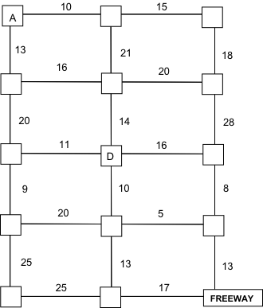
(a) Show the route that has the smallest time delay in the diagram above. (2 marks)
(b) What is this smallest time delay? (1 mark)
(c) The traffic light at point D has malfunctioned. This has increased the waiting period by a further 20 seconds for all traffic entering this set of traffic lights. Show the route that I should have taken that day. (3 marks)

Question 8 (8 marks)
A road system is to connect 6 new sub–divisions A, B, C, D, E and F on the coast.  A can be connected to B, C and D.  B can be connected to D, E and F.  D can be connected to E.  E can be connected to F. | 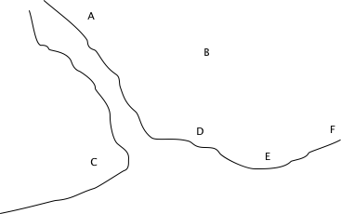

(a) Use the diagram above, draw a network to show this information. (1 mark)

The cost (in $millions) of constructing roads and bridges between towns is given in the table below.
 | A | B | C | D | E | F
A |  | 20 | 55 | 23
B | 20 |  |  | 15 | 13 | 14
C | 55
D | 23 | 15 |  |  | 10
E |  | 13 |  | 10 |  | 5
F |  | 14 |  |  | 5

(b) Determine the least costly way to link each of the subdivisions using Prim’s algorithm.
(5 marks)

(c) Determine the least cost. (2 marks)

Question 9 (13 marks)
Seven adults on a diet plan had their weight reduction recorded against the time (in months) on the diet plan. The table below displays this information.

Adult | 1 | 2 | 3 | 4 | 5 | 6 | 7
Time on plan (t months) | 3 | 4 | 6 | 6 | 7 | 9 | 12
Weight reduction (w kg) | 5 | 5∙5 | 7∙3 | 7∙5 | 8∙2 | 9∙8 | 11∙1

(a) Draw a scatter diagram on the grid below. (4 marks)

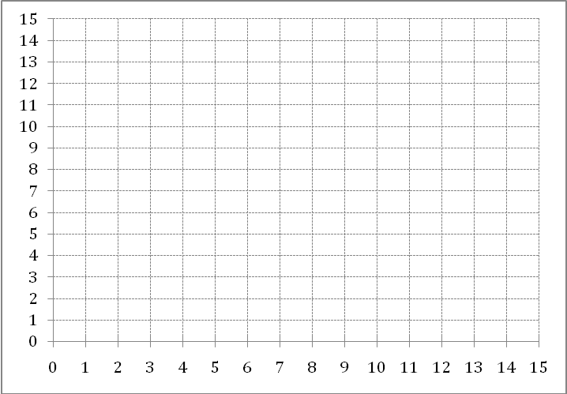

(b) Draw the line of best fit by eye. (1 mark)

(c) Calculate the line of best fit. (2 marks)

(d) Predict the weight loss of an adult who has been on the diet plan for 5 months. (2 marks)

(e) Comment on the reliability of your prediction in (c). Give reasons. (2 marks)

(f) Would it be correct to assume that any person on the diet plan would have the same results?
Give a reason. (2 marks)
Question 10 (8 marks)
Helen records the time to complete her one kilometre run, always heading East, on 6 separate occasions. These times are listed below.
5min 10sec , 6min 11sec , 5min 8sec , 5min 7sec , 4min 25sec , 5min 12sec
(a) On one occasion Helen had a strong head wind (ie the wind was blowing in the opposite direction to the direction of the run). Which time is this likely to be? (1 mark)

(b) On another occasion Helen had a strong tail wind (i.e. the wind was blowing in the same direction to the direction of the run). Which time is this likely to be? (1 mark)

(c) Determine the mean and median time for the one kilometre run. (2 marks)

Helen continues recording her runs on 20 more occasions. Unbeknown to her, Tom has a special recording device that will record her run times in minutes to two decimal places.
(d) Who has the most accurate recording device, Tom or Helen? Explain your answer.
(2 marks)

(e) Is there likely to be a modal time for either methods of recording? Explain your answer.
(2 marks)

Question 11 (9 marks)
The accounts manager of a large firm records the annual income of all the firm’s non management employees. The information is displayed in the table below.
Income ($ 000) | Midpoint | Number of employees
0 ≤ x < 10 | 5 | 35
10 ≤ x < 20 | 15 | 293
20 ≤ x < 30 | 25 | 365
30 ≤ x < 40 | 35 | 120
40 ≤ x < 50 | 45 | 120
50 ≤ x < 60 | 55 | 33
60 ≤ x < 70 | 65 | 20
70 ≤ x < 80 | 75 | 14

(a) Is it possible to determine the range in annual incomes? Explain your answer. (1 mark)

(b) What is the modal class? (1 mark)

(c) What is the median class? (2 marks)

(d) Are there any outliers in the table? Explain your answer. (2 marks)

(e) Give a general description of the spread of annual incomes using words such as gaps, clusters, dense/less dense regions. (2 marks)

(f) What percentage of the employees earn less than $30 000 per annum? (1 mark)
Question 12 (7 marks)
Jim borrows $7000 from his sister Sue. Jim wants to repay the money back over 4 years including a simple interest charge of 3% per annum calculated on the $7000.
(a) Determine how much Jim must repay his sister. (2 marks)

(b) If Jim makes monthly repayments, how much should these repayments be? (1 mark)

(c) If Jim makes weekly repayments, how much should these repayments be? (1 mark)

Sue has told Jim that because she is such a great sister he can repay the full amount at the end of 4 years (i.e. he does not make any repayments during the 4 years) but interest would be compounded annually at 3·5% pa.
(d) Showing all working, determine which is the best deal. (3 marks)
Question 13 (4 marks)
Bohdan Iamakuty has entered Australia on a working visa from the Ukraine. His employer is required to withhold tax on his fortnightly earnings according to the tax rates indicated in the table below. Tax withheld is always rounded to the nearest dollar.
Foreign resident tax rates

Fortnightly earnings$ |  |  | Fortnightly rate
0 | to | 1 346 | 29 cents for each dollar of earnings
1 347 | to | 3 077 | $390 plus 30 cents for each $1 of earnings over $1 346
3 078 | to | 6 923 | $910 plus 38 cents for each $1 of earnings over $3 077
6 924 | & | over | $2 371 plus 45 cents for each $1 of earnings over  $6 923

(Source: Australian Taxation Office NAT 1006-05.2009)
(a) In a particular fortnight Bohdan earned $3 079. Calculate the tax withheld by his employer for this fortnight.
(1 mark)

(b) The following fortnight Bohdan earned $5 620. Calculate the tax withheld by his employer for this fortnight. (3 marks)

Question 14 (11 marks)
The inside of a garden arch can be modelled by the equation H = −2d² + 7d − 3 where H is the height of the arch and d is the distance from the outside wall of a house. Assume the arch is on level (horizontal) ground.
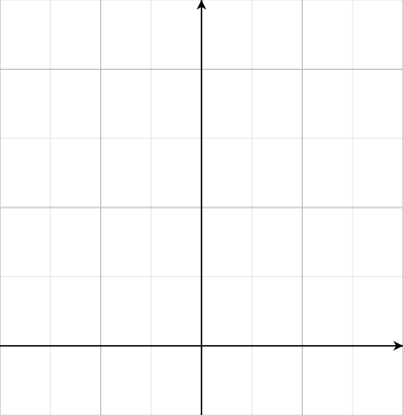
(a) Sketch the arch on the axes above. (5 marks)
(b) How far from the house wall are the outside feet of the arch? (1 mark)

(c) What is special about the equation d =1·75? (1 mark)

(d) Determine the inside height of the arch. (1 mark)

(e) A horizontal beam is to be positioned 2·5 metres above ground level inside the arch to stabilize it. What is the length of this beam? (3 marks)

Question 15 (9 marks)
The network below shows a rail system which connects a mine to a port. The numbers give the maximum volume of ore (in 00's tonnes per day) that can be carried on each section of the rail system.
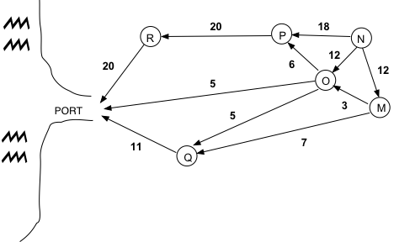
(a) Determine the location of the mine. (1 mark)

(b) Determine the maximum volume of ore that can be transported from the mine to the port.
(3 marks)
(c) The maximum volume can be confirmed by a minimal cut. Show this cut in the diagram and compare it to two other cuts which do not give this minimum. (2 marks)

(d) Projected sales of 4000 tonnes of ore per day requires the system to be upgraded. However there is only enough money to upgrade one of the sections. Determine the possible section and by how much. (3 marks)
Additional working space
Additional working space
SOLUTIONS

Question 6 (5 marks)
An experiment is designed to study the side effects of two drugs. A group of 90 subjects is assigned to two drug groups. After being given the specified drug the side effects are classified as follows.
 |  | Side Effect
 | Major |  | Minor | None
Drug A | 13 |  | 15 | 17 | 45
Drug B | 8 |  | 21 | 16 | 45
 | 21 |  | 36 | 33 | 90

(a) Complete all missing entries in the table. √ (1 mark)

A person is randomly selected from this group. Determine in its simplest form the probability the person will experience:
(b) a major side effect using drug A. (1 mark)
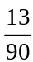 √

(b) no side effect with either drug. (1 mark)
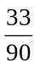
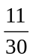 √

(c) a minor side effect if they used drug B. (2 marks)
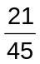 √
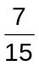 √

Question 7 (6 marks)

There are several alternative routes from my home at A to an entry point on the Kwinana Freeway. Distance is not a factor however time delays at traffic lights create the most concern. I timed these delays (in seconds) and recorded the information on a map as shown.  √ √ | 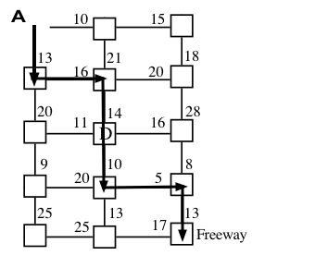
(a) Show the route that has the smallest time delay in the diagram above. (2 marks)
(b) What is this smallest time delay? (1 mark)
71 seconds √

(c) The traffic light at point D has malfunctioned. This has increased the waiting period by a further 20 seconds for all traffic entering this set of traffic lights. Show the route that I should have taken that day. | 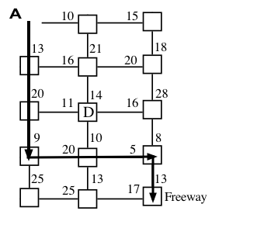
(3 marks)

Question 8 (8 marks)
A road system is to connect 6 new sub–divisions A, B, C, D, E and F on the coast.  A can be connected to B, C and D.  B can be connected to D, E and F.  D can be connected to E.  E can be connected to F. | 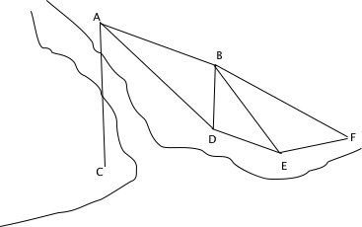

(a) Use the diagram above, draw a network to show this information. (1 mark)

The cost (in $millions) of constructing roads and bridges between towns is given in the table below
 | A | B | C | D | E | F
A |  | 20 | 55 | 23
B | 20 |  |  | 15 | 13 | 14
C | 55
D | 23 | 15 |  |  | 10
E |  | 13 |  | 10 |  | 5
F |  | 14 |  |  | 5

(b) Determine the least costly way to link each of the subdivisions using Prim’s algorithm.
one mark for each step √ √ √ √ √ (5 marks)
Solution A to C, A to B, B to E, E to D and E to F

(c) Determine the least cost. (2 marks)
least cost = $103 million √ √
Question 9 (13 marks)
Seven adults on a diet plan had their weight reduction recorded against the time (in months) on the diet plan. The table below displays this information.

Adult | 1 | 2 | 3 | 4 | 5 | 6 | 7
Time on plan (t months) | 3 | 4 | 6 | 6 | 7 | 9 | 12
Weight reduction (w kg) | 5 | 5∙5 | 7∙3 | 7∙5 | 8∙2 | 9∙8 | 11∙1

(a) Draw a scatter diagram on the grid below. (4 marks)

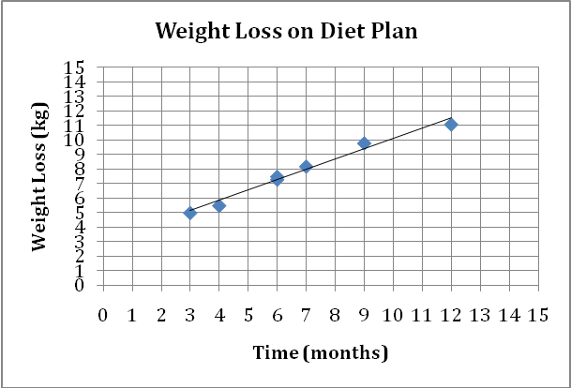

(b) Draw the line of best fit by eye. (1 mark)

(c) Calculate the line of best fit. (2 marks)

w = 0∙7t + 3 √ √

(d) Predict the weight loss of an adult who has been on the diet plan for 5 months. (2 marks)

6∙55 kg √ √

(e) Comment on the reliability of your prediction in (c). Give reasons. (2 marks)

High reliability because of interpolation and points are close to the line of best fit. √ √

(f) Would it be correct to assume that any person on the diet plan would have the same results?
No. The sample is small and we cannot assume that all people react in the same way.
(2 marks)
√ √
Question 10 (8 marks)
Helen records the time to complete her one kilometre run, always heading East, on 6 separate occasions. These times are listed below.
5min 10sec , 6min 11sec , 5min 8sec , 5min 7sec , 4min 25sec , 5min 12sec
(a) On one occasion Helen had a strong head wind (ie the wind was blowing in the opposite direction to the direction of the run). Which time is this likely to be? (1 mark)
6min 11sec √

(b) On another occasion Helen had a strong tail wind (ie the wind was blowing in the same direction to the direction of the run). Which time is this likely to be? (1 mark)
4min 25sec √

(c) Determine the mean and median time for the one kilometre run. (2 marks)
mean = 5 min 12·17 sec median = 5 min 9 sec

Helen continues recording her runs on 20 more occasions. Unbeknown to her, Tom has a special recording device that will record her run times in minutes to two decimal places.
(d) Who has the most accurate recording device, Tom or Helen? Explain your answer.
Tom √ While 0·50 = 30 sec 0·51 = 30·6 sec or some other correct explanation √
(2 marks)

(e) Is there likely to be a modal time for either methods of recording? Explain your answer)
No. Recording times will usually be different although there may be a slim chance (2 marks)
√ √
Question 11 (9 marks)
The accounts manager of a large firm records the annual income of all the firm’s non management employees. The information is displayed in the table below.
Income ($ 000) | Midpoint | Number of employees
0 ≤ x < 10 | 5 | 35
10 ≤ x < 20 | 15 | 293
20 ≤ x < 30 | 25 | 365
30 ≤ x < 40 | 35 | 120
40 ≤ x < 50 | 45 | 120
50 ≤ x < 60 | 55 | 33
60 ≤ x < 70 | 65 | 20
70 ≤ x < 80 | 75 | 14

(a) Is it possible to determine the range in annual incomes? Explain your answer. (1 mark)
No. We cannot determine the exact minimum or maximum within the bounds 0 – 10 – or 70 – 80 – √

(b) What is the modal class? (1 mark)
20 ≤ x < 30 √
(c) What is the median class? (2 marks)
20 ≤ x < 30 √ √
(d) Are there any outliers in the table? Explain your answer. (2 marks)
no √ The incomes …. √

(e) Give a general description of the spread of annual incomes using words such as gaps, clusters, dense/less dense regions. (2 marks)
The annual incomes cluster around $20 000 to $30 000 with the majority of employees earning between $10 000 to $30 000. This is where the earning are most dense. There are no gaps in the incomes. √ √

(f) What percentage of the employees earn less than $30 000 per annum? (1 mark)
69∙3 % √

Question 12 (7 marks)
Jim borrows $7000 from his sister Sue. Jim wants to repay the money back over 4 years including a simple interest charge of 3% per annum calculated on the $7000.
(a) Determine how much Jim must repay his sister. (2 marks)
3% of $7000 × 4 √
= $840
Amount repaid = $7840 √
(b) If Jim makes monthly repayments, how much should these repayments be? (1 mark)
≈ $163·33

(c) If Jim makes weekly repayments, how much should these repayments be? (1 mark)
$37·69

Sue has told Jim that because she is such a great sister he can repay the full amount at the end of 4 years (ie he does not make any repayments during the 4 years) but interest would be compounded annually at 3·5% pa.
(d) Showing all working, determine which is the best deal. (3 marks)
1∙035⁴ × $7000 = $8032∙66 √ √

Sue really isn’t such a great sister. Jim had the best suggestion. √
Question 13 (4 marks)
Bohdan Iamakuty has entered Australia on a working visa from the Ukraine. His employer is required to withhold tax on his fortnightly earnings according to the tax rates indicated in the table below. Tax withheld is always rounded to the nearest dollar.
Foreign resident tax rates
Fortnightly earnings$ |  |  | Fortnightly rate
0 | to | 1 346 | 29 cents for each dollar of earnings
1 347 | to | 3 077 | $390 plus 30 cents for each $1 of earnings over $1 346
3 078 | to | 6 923 | $910 plus 38 cents for each $1 of earnings over $3 077
6 924 | & | over | $2 371 plus 45 cents for each $1 of earnings over  $6 923

Source: Australian Taxation Office NAT 1006-05.2009
(a) In a particular fortnight Bohdan earned $3 079. Calculate the tax withheld by his employer for this fortnight.
$911 because the amount is rounded to the nearest dollar (i.e. from $910·76) √ (1 mark)

(b) The following fortnight Bohdan earned $5 620. Calculate the tax withheld by his employer for this fortnight. (3 marks)
Extra above $3077 is $2543 √

Tax withheld = $910 + $2543 × 0∙38 = $1876∙34 √

= $1876 √
Question 14 (11 marks)
The inside of a garden arch can be modelled by the equation H = −2d² + 7d − 3 where H is the height of the arch and d is the distance from the outside wall of a house. Assume the arch is on level (horizontal) ground.
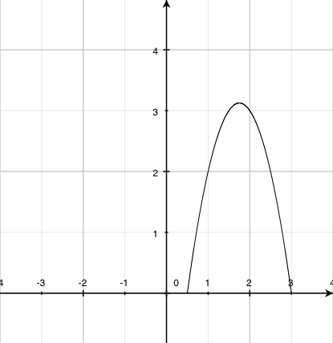
(a) Sketch the arch on the axes above. (5 marks)
Roots √ √ Turning point √ end points √ General shape √
(b) How far from the house wall are the outside feet of the arch? (1 mark)
At 0·5m and 3m √
(c) What is special about the equation d =1·75? (1 mark)
It is the axis of symmetry for the arch.
(d) Determine the inside height of the arch. (1 mark)
3·125 m √
(e) A horizontal beam is to be positioned 2.5 metres above ground level inside the arch to stabilize it. What is the length of this beam? (3 marks)
Points of intersection is 1·19 and 2·31 √ √
Length of the beam is 1·12 m √
Question 15 (9 marks)
The network below shows a rail system which connects a mine to a port. The numbers give the maximum volume of ore (in 00's tonnes per day) that can be carried on each section of the rail system.
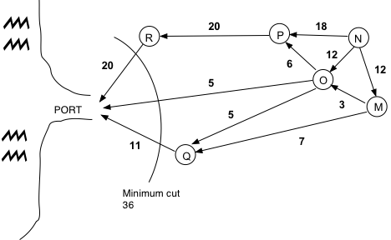
(a) Determine the location of the mine. (1 mark)
at N √
(b) Determine the maximum volume of ore that can be transported from the mine to the port.
3600 tonnes √ 2 marks for values in the diagram √ √ (3 marks)

(c) The maximum volume can be confirmed by a minimal cut. Show this cut in the diagram and compare it to two other cuts which do not give this minimum. (2 marks)
Minimum cut is at the port or at ……√ Student gives two other cuts with given values. √

(d) Projected sales of 4000 tonnes of ore per day requires the system to be upgraded. However there is only enough money to upgrade one of the sections. Determine the possible section and by how much. (3 marks)
O to port √ √ by 400 tonnes per day √

